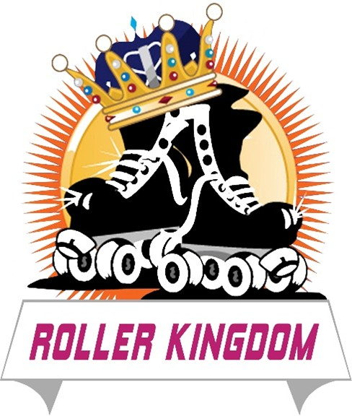
ROLLER KINGDOM
Outdoor Mobile Roller Rink Employment Application
Position Applying For: ______________________________________
Date: ____________________
Applicant Information
Full Name: ______________________________________
Address: ______________________________________
City, State, ZIP: ______________________________________
Phone Number: ______________________________________
Email Address: ______________________________________
Preferred Method of Contact: ______________________________________
Employment Interest
Type of employment desired:
- Part-time
- Seasonal
- Event-based
Available Start Date: ______________________________________
Are you available to work flexible hours, including evenings, weekends, and holidays, based on event bookings and business needs? Yes ___ No ___
Please list your general availability:
Monday: ______________________________________
Tuesday: ______________________________________
Wednesday: ______________________________________
Thursday: ______________________________________
Friday: ______________________________________
Saturday: ______________________________________
Sunday: ______________________________________
Position Summary
Roller Kingdom Mobile Roller Rink is seeking energetic, dependable, and customer-friendly team members to join our event crew. This is a part-time, seasonal, event-based position for an outdoor mobile roller rink business. Team members assist with setup and breakdown, loading and unloading equipment, skate rental support, and customer service during community and private events.
Position Requirements
Are you at least 16 years old? Yes ___ No ___
Do you have reliable transportation to event sites? Yes ___ No ___
Are you able to perform light manual labor? Yes ___ No ___
Are you able to lift and carry at least 50 pounds? Yes ___ No ___
Are you comfortable working outdoors in varying weather conditions? Yes ___ No ___
Are you comfortable standing for extended periods of time during events? Yes ___ No ___
Are you reliable for early setup and late breakdown at event locations? Yes ___ No ___
Are you able to work as part of a team to help ensure successful events? Yes ___ No ___
Eligibility
Are you legally authorized to work in the United States? Yes ___ No ___
Have you ever worked for Roller Kingdom before? Yes ___ No ___
If yes, when? ______________________________________
Experience
Do you have experience in any of the following?
- Customer service
- Event setup and breakdown
- Equipment loading and unloading
- Cash handling
- Rental equipment organization
- Working with children and families
- Food service / concessions
- Community events
- Fast-paced event environments
Job Responsibilities
This position may include the following responsibilities:
- Assist with setup and breakdown of the portable roller rink
- Load and unload equipment
- Organize and distribute rental skates
- Help guests with skate sizing and basic questions
- Provide excellent customer service during events
- Work as part of a team to ensure successful events
Work History
Most Recent Employer: ______________________________________
Job Title: ______________________________________
Dates Employed: ______________________________________
Supervisor Name: ______________________________________
Phone Number: ______________________________________
Reason for Leaving: ______________________________________
Main Duties: ______________________________________
Previous Employer: ______________________________________
Job Title: ______________________________________
Dates Employed: ______________________________________
Supervisor Name: ______________________________________
Phone Number: ______________________________________
Reason for Leaving: ______________________________________
Main Duties: ______________________________________
Skills and Qualifications
Do you know how to roller skate? Yes ___ No ___
No skating experience is required, but are you willing to learn? Yes ___ No ___
Are you comfortable helping guests in a fun, family-friendly event environment? Yes ___ No ___
Do you have a friendly, positive attitude and strong teamwork skills? Yes ___ No ___
Do you have any certifications such as CPR, First Aid, or Food Handler training? ______________________________________
Why do you want to work for Roller Kingdom? ______________________________________
______________________________________
______________________________________
References
Reference 1 Name: ______________________________________
Relationship: ______________________________________
Phone Number: ______________________________________
Reference 2 Name: ______________________________________
Relationship: ______________________________________
Phone Number: ______________________________________
Emergency Contact
Name: ______________________________________
Relationship: ______________________________________
Phone Number: ______________________________________
Applicant Statement
I certify that the information provided in this application is true and complete to the best of my knowledge. I understand that employment with Roller Kingdom is part-time, seasonal, and event-based, and that hours may vary based on event bookings, weather, seasonal demand, and business needs. I understand that this position may require light manual labor, lifting and carrying at least 50 pounds, working outdoors, and assisting with setup and breakdown for mobile rink events.
I understand that false or misleading information may result in disqualification from consideration or termination of employment if hired.
Applicant Signature: ______________________________________
Date: ____________________

ROLLER KINGDOM JOB POSTING
Join the Roller Kingdom Team
Roller Kingdom Mobile Roller Rink is looking for energetic, dependable, and customer-friendly individuals to join our seasonal event crew. This is a part-time, event-based position for an outdoor mobile roller rink business.
What You'll Do
- Assist with rink setup and breakdown
- Load and unload equipment
- Organize rental skates
- Help guests with skate sizing and basic questions
- Provide excellent customer service during events
- Work as part of a team to ensure successful events
Qualifications
- At least 16 years old
- Reliable transportation preferred
- Ability to lift at least 50 pounds
- Friendly, positive attitude
- Weekend availability preferred
- No skating experience required - training provided
How to Apply
Phone: 240-405-6828
Email: rmcintosh@rollerkingdom.net or ronaldmcintodh@hotmail.com
Website: Roller Kingdom Mobile Roller Rink
Veteran-owned business

